Historic Hunter Hills Neighborhood Association App
Prometheus Team No. 6305
Exahel Castaneda, Jeremiah Ochieng, Mark Volovoi, Lawson Crutcher
Client: Maya Teague
Repository: https://github.com/Lawson-C/HHHA-App-6305
______________________________________________________________________________

Table of Contents

Contents
Historic Hunter Hills Neighborhood Association App 1
Table of Contents 1
Historic Hunter Hill Neighborhood Association App Figures 3
Front Matter 4
Background 4
Document Summary 4
Terminology 4
Static System Architecture 5
Introduction 5
System Architecture & Rational 5
Static Architecture UML Diagram 7
Data Design 9
Introduction 9
Entity Relationship Diagram 9
File Use 10
Data Exchange 10
Data Security 10

Historic Hunter Hill Neighborhood Association App Figures
Figure 1. UML Diagram of Static Architecture represents the static architecture of the HHHNA application using a UML component diagram. A component diagram was selected because it provides a high-level representation of the major components of the system and the dependencies between them. 1
Figure 2. Entity Relationship Diagram of Data Design represents the major entities that utilize the database surveyed. A solid underline is for PKs, and a dashed underline is for FKs. 1

Front Matter

Background
We are creating a mobile application for the Historic Hunter Hills Neighborhood Association (HHHNA). The application is meant to serve Hunter Hills residents and surrounding Atlanta District 3 neighborhoods. The issue identified by the client is that important neighborhood information and resources are spread or difficult to access. Our application aims to provide residents with more centralized access to community information, so inquiries can be answered in a timely matter. Therefore, our application aims to provide the solution to this issue- we wish to provide a mobile application where residents can access neighborhood information and resources conveniently. The major functions of our application involve: housing resources, blight reporting, environmental information, community events accessible through an interactable calendar, resource library, administrative content management, and alerts/push-notifications.

Document Summary
The Static System Architecture section aims to show the major components that make up the HHHNA application. It displays the relationships/dependencies between those components and explains the architectural organization and reasoning surrounding it.
The Dynamic System Architecture section describes how the system components interact during application workflows, focusing on runtime behavior and sequences of interactions. This section will be integrated into version 2 of the detailed design.
The Data Storage Design section explains how the HHHNA App database is managed and structured. It describes how data is stored and organized, including uploaded file usage such as uploaded images/attachments. Further, data exchange between parts of the systems and data security/privacy considerations are mentioned.
The UI Design section describes the app's major screens and navigation. It covers how users interact with the application and usability/design considerations. This section will be integrated into version 2 of the detailed design.

Terminology
Term | Definition
9mile | An external neighborhood/property data source that is used for information regarding building and tree-removal permits. The Historic Hunter Hills Neighborhood Association plans to integrate it as one of its external data sources.
API | API stands for Application programming Interface. It allows communication between different services/software. In our application, we will connect different APIs like 9mile, mapping, and environmental/weather data to implement some features.
Expo | Tool/platform used with React Native that helps with Android and iOS development/testing. It'll be used to run and test the HHHNA mobile app.
Supabase | A backend platform that provides the project's database/data storage. It provides user authentication for account creation and login and is built around a PostgreSQL relational database. It'll be used to store application information related to users and other functionalities.
React Native | Framework for building mobile applications, serving as our frontend for the HHHNA app. It supports Android and iOS from a shared codebase.
Strapi | A headless Content Management System (CMS) that is used as the backend/content-management system for our application. It allows admins to manage app content without directly changing mobile application code.

Static System Architecture

Introduction
The Historic Hunter Hills Neighborhood Association application is a residential focused system designed to serve residents of the Historic Hunter Hills Neighborhood District 3. The system aims to provide centralized, up-to-date access to community resources, including housing, business support, and health resources. It also provides community notice functions of thought features such as blight reporting, environmental information, and community calendar notifications. Administrative controls support and moderate the application's content, user submitted information, and community resources to maintain a secure and reliable environment.
The main objective of the system is to consolidate community information and services that would be distributed across multiple platforms into an easy-to-use single application. The system is designed to support both resident and admin using provided internal information as well as external data. The architecture must therefore support user authentication and authorization, persistent data storage, external data integration, administrative content management, and secure access to user-specific information.

System Architecture & Rational
- Front End: React Native
- Back End: Strapi
- Database: Supabase
- External Databases/APIs: 9mile, Map/Geolocation API, weather API, EPA AirNow API
To meet the goals specified, the system uses components based on the architecture above. Due to client requests, the application must run on both Android and IOS mobile devices, so the choice of React Native for the frontend was made. Its main responsibilities serve as displaying the application's content and providing interfaces for features listed in the introduction.
For the backend, Strapi manages both the backend and content management of the system. It provides an interface for managing application content and allows the frontend to access backend functionality through APIs. This choice for Strapi over other backend systems like Payload was made with administrative management of information in mind as admins should be able to control information such as community resources, calendar events, and blight report management in an easy fashion.
Supabase provides persistent data storage and authentication services for the application. Information such as user accounts, bight reports, event information, notification preferences, and other persistent records can be maintained through the database. Authentication and authorization mechanisms are used to restrict access to user-specific and administrator-only functions. Due to picking React Native for the frontend, Supabase was a preferable option as it has an official path. The way the information on the app is also set up through its relationships such as users being able to create reports or event reminders, Supabase's PostgreSQL is perfect for modeling this. As well as Supabase's Row Level Security being able to enforce rules such as "users can't see other user's housing questions" or "admins have additional privileges" at the database level rather than relying purely on the frontend.
The application depends on external data to provide information that is not directly maintained by HHHNA admins. The 9 Mile APi provides city development information, while mapping services support location-based features such as blight reports. Weather and environmental APIs, including EPA AirNow, may provide current environmental information displayed within the application.
Security is incorporated throughout the architecture because the system stores user information and includes functionality restricted to admins. Authentication is required for account-specific functions, while authorization and role-based access controls distinguish resident and admin permissions. User-specific information must be protected from unauthorized access, and admin operations must verify that the requesting account has the appropriate permissions. External API credentials and other sensitive configuration information should also be securely rather than exposed through the frontend application. No broad access to database information is ever accessible through client-side, and read endpoints are only created for public-accessible data.

Static Architecture UML Diagram
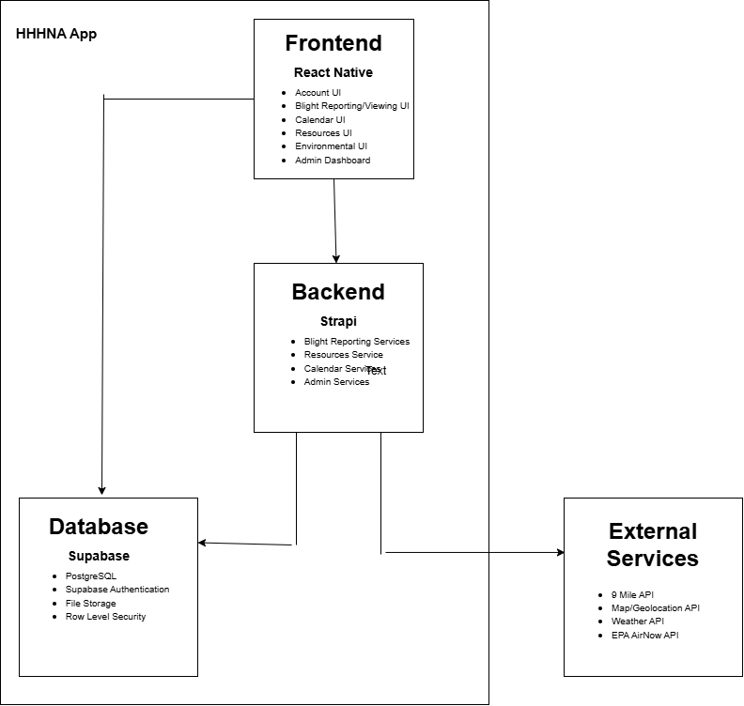
Figure 1. UML Diagram of Static Architecture represents the static architecture of the HHHNA application using a UML component diagram. A component diagram was selected because it provides a high-level representation of the major components of the system and the dependencies between them.
The React Native frontend contains the user front facing interfaces, including account management, blight reporting and viewing, the community calendar, environmental information, notification, and administrative dashboard. The Resources UI represents the interfaces through which residents can access community resources such as housing, business support, health, and other services provided through the application.
The frontend depends on the Strapi backend for the application services and content management. The backend contains services corresponding to the application's major functionality, including blight reporting, community resources, calendar management, notifications, and admin functions. These services provide the separation between the user-facing application and the system's persistent and externally sourced data.
Supabase provides the system's persistent PostgreSQL database, authentication, and file storage. The React Native frontend directly depends on Supabase for user authentication, while backend services depend on Supabase for persistent application data and stored files. Authentication and authorization are used to restrict access to user-specific and administrative services.
The backend also depends on external APIs and services to obtain information not maintained directly by HHHNA. These services include 9 Mile API for development information, mapping and geolocation services for location-based functions (blight reporting), and weather and EPA AirNow services for environmental information.

Data Design

Introduction
The HHHNA application requires persistent storage for information like user accounts, housing resources, and calendar events. Information that is uploaded such as blight reports and their associated images as well as external information from the APIs like the weather API and EPA AirNow API needs a place to be stored. Supabase PostgreSQL works as the application's relational database while Supabase Storage gives a place to store uploaded files. Data is then exchanged between system components and external services to provide effective app experience for users.

Entity Relationship Diagram
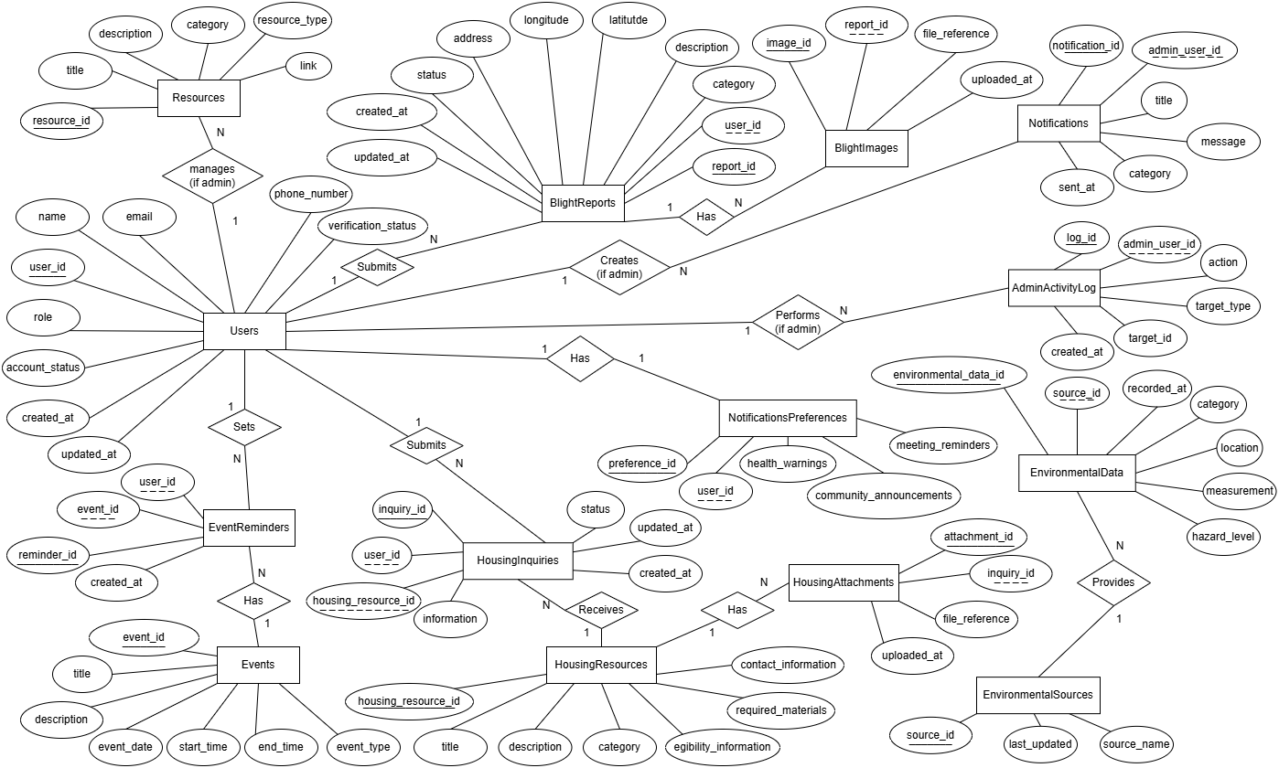
Figure 2. Entity Relationship Diagram of Data Design represents the major entities that utilize the database surveyed. A solid underline is for PKs, and a dashed underline is for FKs.
Here is a list of our major entities:
- Users: Stores account/profile information, role, verification, and account status.
- BlightReports: Stores resident-submitted blight reports, descriptions, locations, status, and timestamps.
- BlightImages: Stores references to images associated with blight reports.
- Events: Stores community calendar event information.
- EventReminders: Associates users with events they want reminders for.
- HousingResources: Stores housing programs/resources available to users and their associated details.
- HousingInquiries: Stores user inquiries connected to housing resources.
- HousingAttachments: Stores references to files submitted with housing inquiries.
- NotificationPreferences: Stores each user’s notification settings.
- Notifications: Stores community notifications created by admins.
- Resources: Stores resource library content and links related to education.
- EnvironmentalData and Environmental Sources: store and cache environmental measurements through provided sources.
- AdminActivityLog: Records admin actions.

File Use
Our mobile application uses uploaded images for blight reports. It also allows the usage of uploaded attachments for housing inquiries. The actual uploaded files are stored using Supabase Storage. Database records store a reference to the stored file rather than putting the file itself inside the relational table described, with blight image uploads being checked for valid file type and size. Housing inquiry attachments must remain associated with the correct user who uploaded them. Resource library videos/articles are stored as external links.

Data Exchange
React Native's mobile frontend sends and receives data from the backend. Strapi handles backend and content-management requests from the application. Supabase provides databases, authentication, and storage services. External data comes from API services, providing information associated with mapping, environmental sources, EPA Airnow, and 9mile when applicable. Data exchanged between the frontend/backend is structured as JSON, with communication occurring using HTTPS. We are currently deciding to use API requests more focused on the API requests over HTTPS using JSON, which we may decide to change this approach using forward is Strapi's REST API seems a better alternative.

Data Security
All remote communication uses HTTPS encryptions. Authentication will be handled using Supabase Auth. Passwords shouldn't be stored or transmitted as plaintext, with role-based authorization separating regular users from administrators. Users are only allowed to modify their own account information, calendar reminders, notification of preferences, and private housing inquiries. Admins are allowed to manage resources, housing information, modify/resolve blight reports, create notifications, and manage user/admin privileges.

